Project Report

Product Name | Applied Degree in Software Engineering
Qualification Name (NICF) | Applied Degree in Software Engineering
Product Name | Design, Develop and Test the Community Portal Website
Module Name (NICF) | NICF-Application Implementation

Learner Name |  | Assessor Name
Francis Roel L. Abarca
Date Issued | Completion Date |  | Submitted On
07-17-2023 | 07-24-2023
Project Title | Design, develop and test the Community portal website

Learner declaration
I certify that the work submitted for this assignment is my own and research sources are fully acknowledged.

Student Signature: Date: 07-17-2023

Content
- Project Background
- Project Objective
- Project Scope
- Tools and Platform
- Task 1
- Task 2
- Task 3
- Task 4
- Task 5
- Task 6
- Task 7

- Project Background
ABC Jobs Pte Ltd has approached you to create a data-driven community portal for Software Developers. The goal is to ease collaboration and networking among programmers in various industries. The main responsibility for this project is to design, develop, implement, and document the portal using Spring Boot framework and ReactJS.
Project Objective
The portal will have 2 main user types: Software Programmer and Administrator. The Software Programmer will be able to perform several functions within the community portal, including registration, searching for other programmers based on various parameters, viewing public profiles of users they search, logging in, requesting a forgotten password, and updating their profile page.

The Administrator will have additional responsibilities within the portal, including administering user data, sending bulk email invitations to programmers to register on the community portal, and managing other functionalities. Depending on the time availability, features like Sending messages between users, creating threads with post replies in a message board, posting job opportunities and applying for jobs are to be planned and implemented for the Capstone Project.

Key Pages required for the Capstone Project include:
- Community Portal Home Page
- Registration Page
- Registration Confirmation Page (with Registration Confirmation Email)
- Login Page
- Reset Password Page
- Reset Password Confirmation Page
- Update Profile Page
- Search Users Page
- List Search Results Page
- Public Profile Page

- Project Scope
  - Features to be Tested.
    - Registration
    - Login
    - Reset Password
    - Search Users
    - Homepage Loading Performance
  - Features Not to be Tested.
    - Post a Job
    - Send a Message
    - Creating Threads
    - Apply for Jobs
  - Deliverables
- Test Scope
- Test Strategy
- Test Environment
- Phase Test Plan
- Defect Reporting
- Risk Assessment
- Resource Allocation
- Approval

- Tools and Platform
  - Eclipse IDE for Enterprise Java and Web Developers
  - MySQL Community Edition 8.0 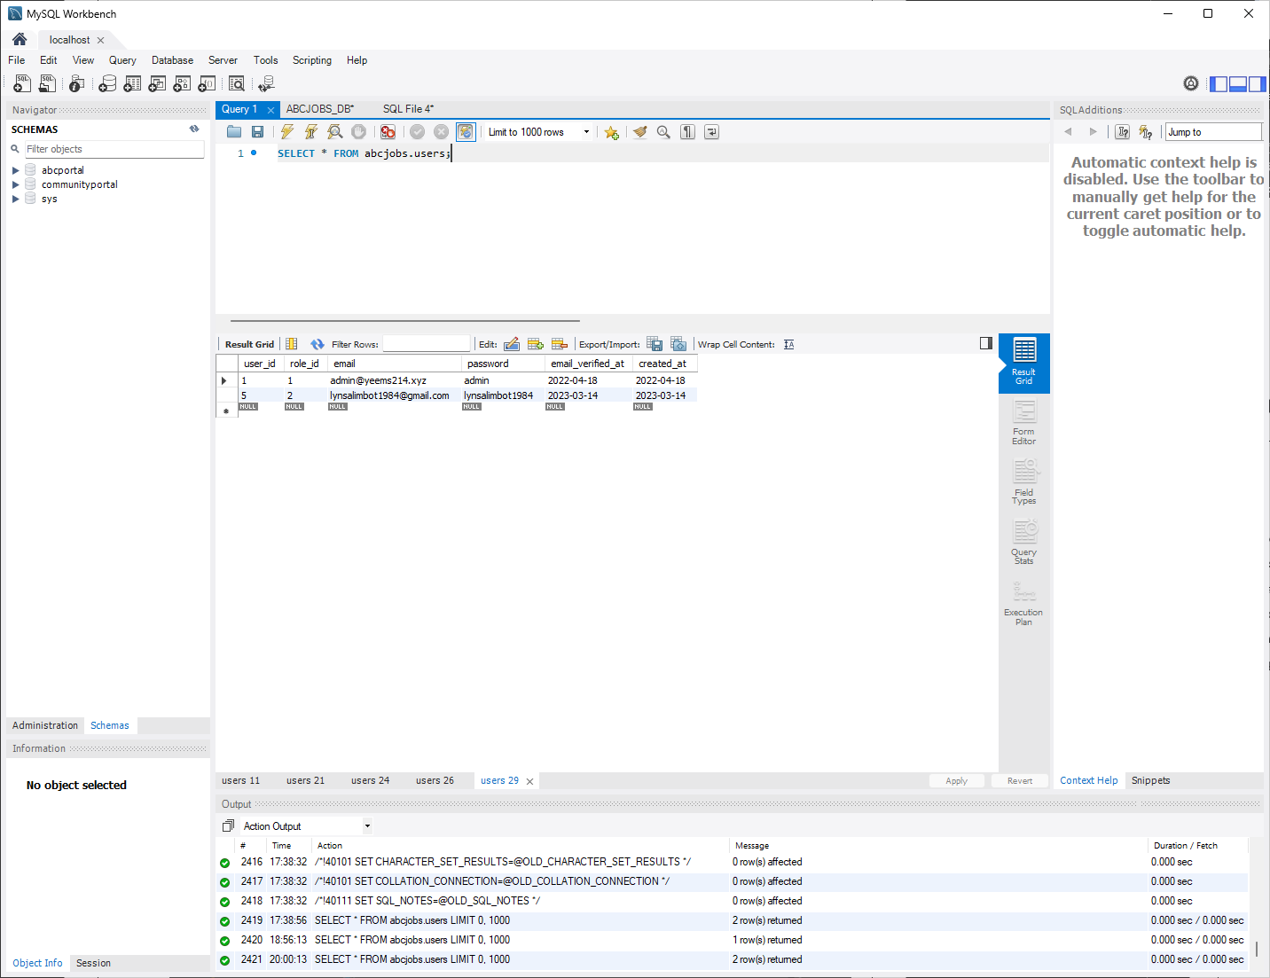
  - Apache Tomcat 9 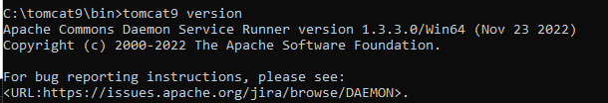
  - Apache Maven
  - Microsoft Hyper-V

- Task 1
Task Statement: Write a brief requirement specification for the Community Portal
Solution:

  - Functional Requirements
No | Requirements | Web Page / Process | Field Detail
1 | Register on the portal | Registration Page | First Name, Last name, Email address, Password, Company Name, City, Country
2 | Receive a Confirmation Email | Registration Confirmation Page | Email Address
3 | View a Thank You Page | Registration Confirmation Page | None
4 | Search for other Software Engineers | Search Users Page | First Name, Last Name, Company Name, City, Country
5 | View the Public Profile of other Software Engineers | Public Profile Page | First name, Last Name, Company Name, City, Country, Skills, Experience, Education
6 | Log in to the portal | Login Page | Email address, password
7 | Reset forgotten passwords | Forgot Password Page | Email Address
8 | Update their profile information after logging in | Update Profile Page | First name, Last Name, Company Name, City, Country, Skills, Education

  - Non-Functional Requirements
No | Requirements | Purpose
1 | Accessibility | Ensure all users have equal access to the system.
2 | Security | Protect user data from unauthorized access, disclosure, modification, or destruction.
3 | Reliability | Ensure that users can access the system whenever they need to.
4 | Navigation | Ensure that users can easily find the information and features they need.
5 | Scalability | Ensure the system can handle an increasing number of users and transactions.

  - Technical Requirements
    - Hardware (Minimum)
CPU: Any x86 CPU with 2 cores
RAM: 4GB
Storage: 40GB SSD
    - Software (Minimum)
Operating System: Windows 10 or Linux
Database: MySQL 8.0
Web Server: Apache Tomcat 9
Java Version: Java 11.0.8
    - Database
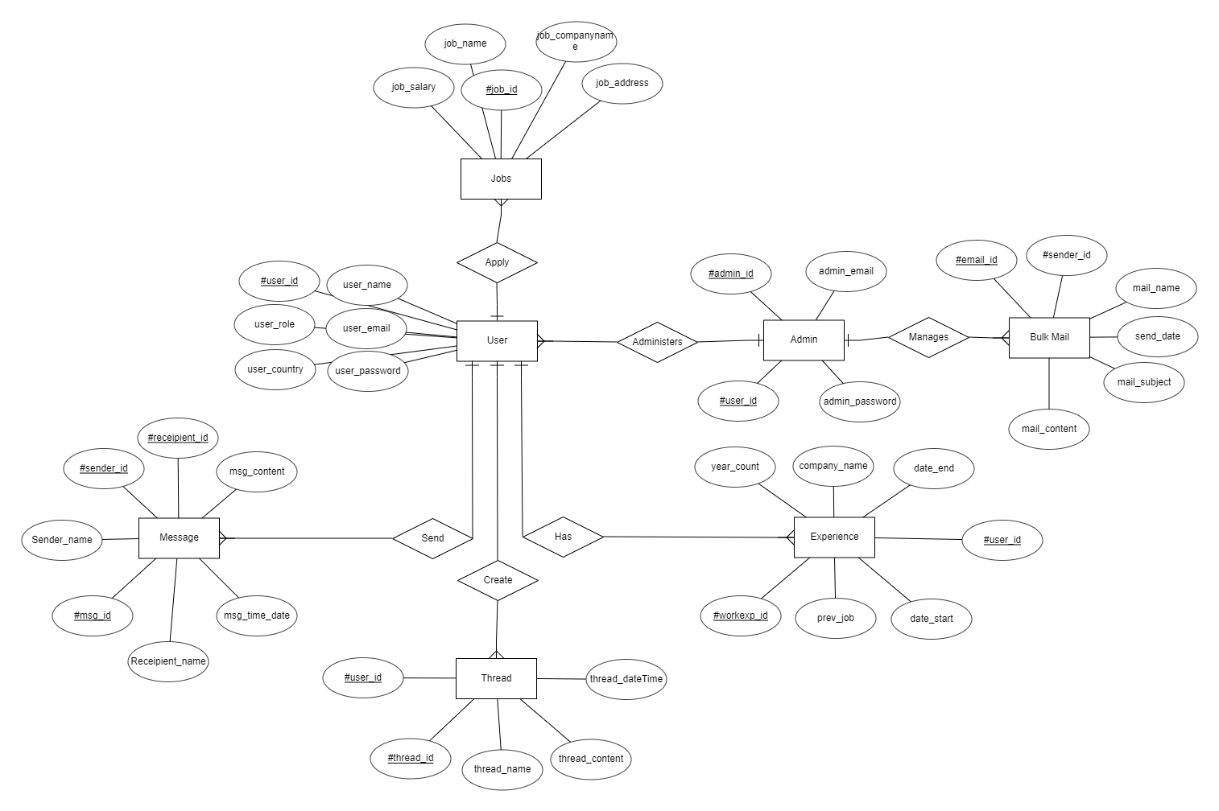

  - Justify the chosen SDLC methodology with pros and cons.
The chosen SDLC methodology for this project is the Agile Software Development approach:
Pros:
- Flexibility
    - Agile methodologies allow for changes in requirements or priorities during the development process without incurring significant additional costs.
- Customer Involvement
    - Agile approaches emphasize close collaboration with customers, enabling them to provide feedback and adjust as needed throughout the project lifecycle.
- Iterative Development
    - Agile promotes an iterative approach to software development which allows continuous improvement and refinement based on customer input and team expertise.
- Continuous Delivery
    - Agile heavily emphasizes on continuous delivery of working software which allows for early feedback and rapid iteration for its customers.
- Adaptability
    - Agile methodologies are adaptable and can be tailored to suit specific need and constraints of a project or organization.
Cons:
- Lack of Detailed Planning
    - Agile approaches often prioritize flexibility over detailed planning which can lead to challenges in managing expectations and resources effectively.
- Communication Challenges
    - Agile methodologies require more frequent communication among team members and stakeholders which can be challenging for distributed or geographically dispersed teams.
- Training Requirements
    - Adopting agile methodologies often requires significant changes in processes, tools, and mindset, necessitating additional training and support for team members.
- Measurement Challenges
    - Agile approaches may be less amenable to traditional project management metrics and measurement, which could create challenges when reporting progress or evaluating success.
- Risk of Scope Creep
    - The emphasis on customer involvement and iterative development can sometimes result in scope creep, where the project’s requirements continuously expand beyond initial expectations.

  - Project Plan
    - Gantt Table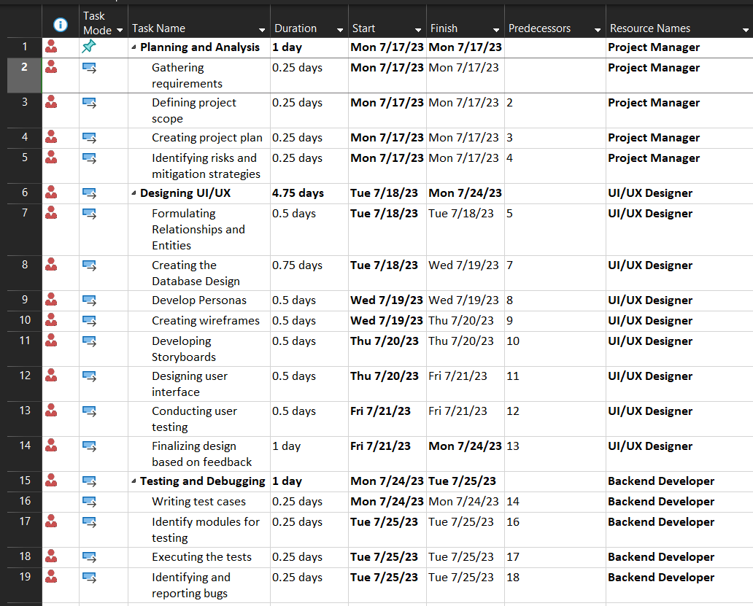
    - Gantt Chart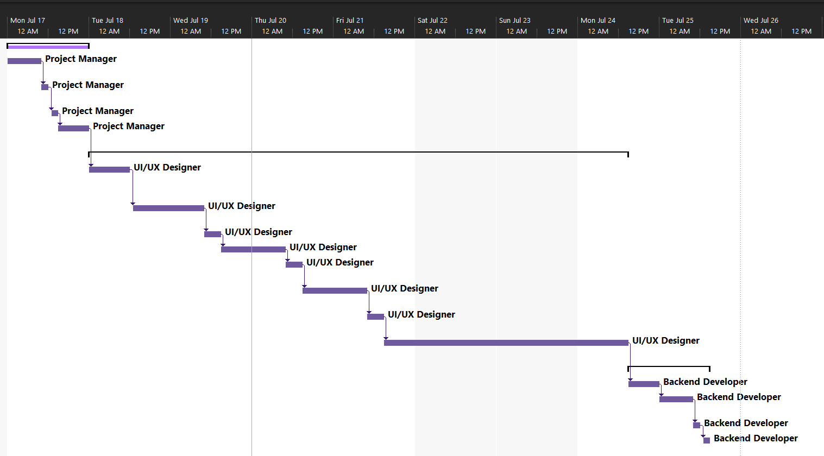

- Task 2
Task Statement: Explain the benefits of 4 testing methods under functional and non-functional categories.
Solution:
1. Functional Testing
Testing Method | Main Benefits
Unit Testing | Unit Testing allows the developer to test each operation the program does. This type of testing allows the developer to easily find bugs, check for exact variables and units if they are parsing data correctly or not.
Compatibility Testing | ﻿Compatibility testing ensures that your software works seamlessly with other systems, devices, or applications. This includes checking for compatibility with different operating systems, browsers, or hardware configurations. By performing compatibility tests, you can identify potential issues and make necessary adjustments to ensure a smooth user experience across various platforms.
Integration Testing | Integration testing focuses on verifying the proper interaction between different components of your software system. This involves ensuring that individual modules, libraries, or services work together as intended when combined with other components. Integration tests help identify any issues related to data flow, error handling, or communication between different parts of your application.
Portability Testing | Portability testing aims to ensure that your software can function effectively across various environments and platforms. This includes checking for compatibility with different hardware architectures, operating systems, or network configurations. By performing portability tests, you can identify potential issues related to platform-specific code or dependencies, allowing you to optimize your software's performance and maintainability in diverse contexts.

2. Non-Functional Testing
Testing Method | Main Benefits
Performance Testing | Performance testing evaluates the speed, responsiveness, and resource utilization of your software under various load conditions. This helps identify any bottlenecks, scalability issues, or other performance-related problems that could negatively impact user experience or system stability. Performance tests can be used to establish benchmarks, set expectations for optimal performance, and guide optimization efforts.
Security Testing | Security testing focuses on identifying potential vulnerabilities in your software's design, implementation, or deployment that could be exploited by malicious actors. This includes checking for weaknesses related to authentication, authorization, data confidentiality, or system integrity. By performing security tests, you can help ensure the safety and privacy of user data, as well as protect your application from unauthorized access, manipulation, or destruction.
Usability Testing | Usability testing aims to evaluate how easily users can navigate, interact with, and accomplish their goals within your software system. This involves observing users as they perform various tasks and gathering feedback on the overall usability, efficiency, and satisfaction of the user experience. By performing usability tests, you can identify areas for improvement related to interface design, functionality, or instructional materials, helping to create more intuitive, accessible, and enjoyable software products.
Reliability Testing | Reliability testing assesses your software's ability to perform consistently and accurately under various conditions and usage scenarios. This includes evaluating the system's resilience in the face of unexpected events, errors, or resource constraints. By performing reliability tests, you can help ensure that your application remains stable, dependable, and consistent over time, providing users with a high level of confidence in its functionality and performance.

- Task 3
Task Statement: Propose relevant tests suitable for the Project Scenario:
Solution:
1. Functional Testing
Test Id | Test Scenario | Test Objective | Technique | Expected Result
1 | TS001 | Ensure users can register to the website. | Functional Testing | After registration, the users will be able to log-in to the system and access their information.
2 | TS002 | Identify when users can Login to the page with non-existing credentials. | Functional Testing | Login will fail and indicate that this user doesn’t exist.
3 | TS003 | Ensure users can post. | Functional Testing | User should be able to see their post on their profile and dashboard.
4 | TS004 | Ensure users can search what they are looking for. | Functional Testing | User should be able to see the person or company they are searching for.
5 | TS005 | Ensure users can reset their password. | Functional Testing | User should be able to replace their password as easy as possible.

 |  | 2. Compatibility Testing
Test Id | Test Scenario | Test Objective | Technique | Expected Result
6 | TS006 | Identify if the community portal looks good on Google Chrome. | Compatibility Testing | The look of the portal and its user experience should be the same.
7 | TS007 | Identify if the community portal looks good on Apple Safari. | Compatibility Testing | The look of the portal and its user experience should be the same.
8 | TS008 | Identify if the community portal looks good on Mozilla Firefox. | Compatibility Testing | The look of the portal and its user experience should be the same.
9 | TS009 | Identify if the community portal looks good on Microsoft Edge | Compatibility Testing | The look of the portal and its user experience should be the same.

 |  | 3. Performance Testing
Test Id | Test Scenario | Test Objective | Technique | Expected Result
10 | TS010 | Ensure the homepage loads in less than 10 seconds. | Performance Testing | Homepage loads in less than 10 seconds.
11 | TS011 | Ensure the Login page loads less than 10 seconds. | Performance Testing | Login page loads in less than 10 seconds.
12 | TS012 | Ensure the Dashboard loads in less than 15 seconds. | Performance Testing | Dashboard loads in less than 15 seconds.
13 | TS013 | Ensure the Profile loads in less than 10 seconds. | Performance Testing | Profile loads in less than 10 seconds.

 |  | 4. Portability Testing
Test Id | Test Scenario |  | Test Objective | Technique | Expected Result
14 | TS014 |  | Check if the website is still usable on an iPhone 14 Pro Max device. | Portability Testing | Portal maintains the same feature-set of the desktop on the iPhone 14 Pro Max device.
15 | TS015 |  | Check if the website is still usable on a 12.9in iPad Pro device. | Portability Testing | Portal maintains the same feature-set of the desktop on the 12.9in iPad Pro device.
16 | TS016 |  | Check if the website is still usable on the 2020 iPhone SE device. | Portability Testing | Portal maintains the same feature-set of the desktop on the 2016 iPhone SE device.
17 | TS017 |  | Check if the website is still usable on a 2019 iPad mini device. | Portability Testing | Portal maintains the same feature-set of the desktop on the 2019 iPad mini device.

- Task 4
Task Statement: Identify appropriate method to compute the testing schedule duration and prepare the test schedule.
Solution:
Web page | Weighting | Functional Points (FP) | Total
Registration | 4 | 5 | 20
Login | 4 | 5 | 20
Dashboard | 4 | 5 | 20
Search | 2 | 3 | 6
Profile | 4 | 3 | 12
Update Profile | 3 | 3 | 9
Admin | 4 | 2 | 8
Forgot Password | 2 | 3 | 6
Reset Password | 4 | 2 | 8
 |  | Total Functional Points | 109
 |  | Estimated person hour per FP | 1 hour
 |  | Total hours needed | 109
 |  | Total days needed | 4

Test Schedule:
Test Schedule ID | 1
Product ID / Name | ABC Jobs Portal
Product Version or Build | 1.0
Present Owner | Francis Abarca
Created On | 7/18/23
Review On | 7/24/23
Review By | Francis Roel Abarca
Review Comments | Site functionalities passed the test.
Current Version | 1.0
Change Details | N/A
Current Status | Approved
Signing Off Authority | Arvinder Kaur

- Task 5
Task Statement: Phase Test Plan
Solution:
No | Task | Start | End | Days
1 | Prepare Test Plan | 7/17/23 | 7/17/23 | 1
2 | Review Test Plan | 7/17/23 | 7/17/23 | 1
3 | Prepare Test Scripts | 7/17/23 | 7/18/23 | 2
4 | Review Test Scripts | 7/18/23 | 7/18/23 | 1
5 | Set up the Test Environment | 7/18/23 | 7/19/23 | 2
6 | Maintain Test Environment | 7/19/23 | 7/19/23 | 1
7 | Establish Test Procedures | 7/19/23 | 7/20/23 | 2
8 | Promote Software from Development to Test Environment | 7/20/23 | 7/21/23 | 2
9 | Execute Testing/Record Faults | 7/21/23 | 7/22/23 | 2
10 | Re-execute Tests as Needed | 7/22/23 | 7/22/23 | 1
11 | Provide Support/Resolve Faults | 7/22/23 | 7/22/23 | 1
12 | Promote Software from Test to Development Environment | 7/22/23 | 7/23/23 | 2
13 | Certify Application for Release to Beta Test Group | 7/23/23 | 7/24/23 | 2

- Task 6
Task Statement: Unit and UAT Test Scripts
Solution:
Test Cases: Functional Testing
Requirements | Test Scenario ID | Test Scenario | Number of test cases
Functional Testing (UAT) | TS001 | Ensure users can register to the website. | 1
Functional Testing (UAT) | TS002 | Identify when users can Login to the page with non-existing credentials. | 1
Functional Testing (UAT) | TS003 | Check if the user can view another user’s profile. | 1
Functional Testing (UAT) | TS004 | Ensure users can search what they are looking for. | 1
 | TS005 | Ensure users can reset their password. | 1

Scenario ID | Test Case ID | Test Case | Preconditions | Test Step | Test Data | Expected Results | Actual Results | Pass / Fail
TS001 | 1 | Ensure users can register to the website. | Implementation of the ABC Jobs portal is complete with all the sites and navigation links running on the server. | - Open ABC Jobs  - Click on Register  - Enter Test Data  - Click Register | First Name: Tristin  Last Name: Rodriguez  Username: tristinr27  Email: tristinr27@gmail.com  Password: tristinr27 | After registration, the users will be able to log-in to the system and access their information. | User successfully logs-in to the portal. | Pass
TS002 | 2 | Identify when users can Login to the page with non-existing credentials. | Implementation of the ABC Jobs portal is complete with all the sites and navigation links running on the server. | - Open ABC Jobs  - Click on Login  - Enter Test Data  - Click Login | Email: adam27@gmail.com  Password: ppasdr27 | Login will fail and indicate that this user doesn’t exist. | Login page doesn’t log the user in. | Pass
TS003 | 3 | Check if the user can view another user’s profile. | Implementation of the ABC Jobs portal is complete with all the sites and navigation links running on the server. | 1. Open ABC Jobs  2. Sign In  3. Click on Search.  4. Type in Test Data.  5. Press Enter  6. Click View Profile | Query: Kervin | User should be able to see the other user’s profile. | User sees other user’s profile. | Pass
TS004 | 4 | Ensure users can search what they are looking for. | Implementation of the ABC Jobs portal is complete with all the sites and navigation links running on the server. | 1. Open ABC Jobs  2. Sign in  3. Click on Search  4. Insert Test Data  5. Click Search | Search Data: Kervin | User should be able to see the person or company they are searching for. | Page properly shows the query they were looking for. | Pass
TS005 | 5 | Ensure users can reset their password. | Implementation of the ABC Jobs portal is complete with all the sites and navigation links running on the server. | 1. Open ABC Jobs.  2. Click on Login  3. Click on “Forgot my Password?”  4. Enter the Test Data.  5. Click Reset  6. Check your Email provider.  7. Click on the link sent to your email.  8. Enter test data for password.  9. Click Reset. | Email: tristinr27@gmail.com  Password: lillybb71 | User should be able to replace their password as easy as possible. | User’s credentials has its password successfully reset. | Pass

Scenario ID | Evidence
TS001
TS002
TS003
TS004
TS005

Test Cases: Compatibility Testing
Requirements | Test Scenario ID | Test Scenario | Number of test cases
Compatibility Testing | TS006 | Identify if the community portal looks good on Google Chrome. | 1
Compatibility Testing | TS007 | Identify if the community portal looks good on Apple Safari. | 1
Compatibility Testing | TS008 | Identify if the community portal looks good on Mozilla Firefox. | 1
Compatibility Testing | TS009 | Identify if the community portal looks good on Microsoft Edge | 1

Scenario ID | Test Case ID | Test Case | Preconditions | Test Step | Test Data | Expected Results | Actual Results | Pass / Fail
TS006 | 6 | Identify if the community portal looks good on Google Chrome. | Implementation of the ABC Jobs portal is complete with all the sites and navigation links running on the server. | 1. Open Google Chrome  2. Open the ABC Jobs Portal | Address: localhost:8080 | The look of the portal and its user experience should be the same. | Look and feel is maintained on Google Chrome. | Pass
TS007 | 7 | Identify if the community portal looks good on Apple Safari. | Implementation of the ABC Jobs portal is complete with all the sites and navigation links running on the server. | 1. Open Safari  2. Open the ABC Jobs Portal | Address: localhost:8080 | The look of the portal and its user experience should be the same. | Look and feel is maintained on Apple Safari. | Pass
TS008 | 8 | Identify if the community portal looks good on Mozilla Firefox. | Implementation of the ABC Jobs portal is complete with all the sites and navigation links running on the server. | 1. Open Mozilla Firefox  2. Open the ABC Jobs Portal | Address: localhost:8080 | The look of the portal and its user experience should be the same. | Look and feel is maintained on Mozilla Firefox. | Pass
TS009 | 9 | Identify if the community portal looks good on Microsoft Edge | Implementation of the ABC Jobs portal is complete with all the sites and navigation links running on the server. | 1. Open Microsoft Edge  2. Open the ABC Jobs Portal | Address: localhost:8080 | The look of the portal and its user experience should be the same. | Look and feel is maintained on Microsoft Edge. | Pass

Scenario ID | Evidence
TS006
TS007
TS008
TS009
Test Cases: Performance Testing
Requirements | Test Scenario ID | Test Scenario | Number of test cases
Performance Testing | TS010 | Ensure the homepage loads in less than 10 seconds. | 1
Performance Testing | TS011 | Ensure the Login page loads less than 10 seconds. | 1
Performance Testing | TS012 | Ensure the Dashboard loads in less than 15 seconds. | 1
Performance Testing | TS013 | Ensure the Profile loads in less than 10 seconds. | 1

Scenario ID | Test Case ID | Test Case | Preconditions | Test Step | Test Data | Expected Results | Actual Results | Pass / Fail
TS010 | 10 | Ensure the homepage loads in less than 10 seconds. | Implementation of the ABC Jobs portal is complete with all the sites and navigation links running on the server. | 1. Open Google Chrome  2. Open ABC Jobs Portal.  3. Press F12 on the keyboard.  4. Click on Network  5. Refresh the page. | Address: localhost:8080  Tool Required: Google Chrome Developer Tool | Homepage loads in less than 10 seconds. | Homepage loaded in <10 seconds. | Pass
TS011 | 11 | Ensure the Login page loads less than 10 seconds. | Implementation of the ABC Jobs portal is complete with all the sites and navigation links running on the server. | 1. Open Google Chrome  2. Open ABC Jobs Portal.  3. Click on Login Page.  4. Press F12 on the keyboard.  5. Click on Network  6. Refresh the page. | Address: localhost:8080  Tool Required: Google Chrome Developer Tool | Login page loads in less than 10 seconds. | Login page loaded in <10 seconds. | Pass
TS012 | 12 | Ensure the Dashboard loads in less than 15 seconds. | Implementation of the ABC Jobs portal is complete with all the sites and navigation links running on the server. | 1. Open Google Chrome  2. Open ABC Jobs Portal.  3. Login to the site with the Test Data.  4. Press F12 on the keyboard.  5. Click on Network  6. Refresh the page. | Address: localhost:8080  Email: tristinr27@gmail.com  Password: lillybb71  Tool Required: Google Chrome Developer Tool | Dashboard loads in less than 15 seconds. | Dashboard page loaded in <15 seconds. | Pass
TS013 | 13 | Ensure the Profile loads in less than 10 seconds. | Implementation of the ABC Jobs portal is complete with all the sites and navigation links running on the server. | 1. Open Google Chrome  2. Open ABC Jobs Portal.  3. Login to the site with the Test Data.  4. Click on Profile.  5. Press F12 on the keyboard.  6. Click on Network  7. Refresh the page. | Address: localhost:8080  Email: tristinr27@gmail.com  Password: lillybb71  Tool Required: Google Chrome Developer Tool | Profile loads in less than 10 seconds. | Profile page loaded in <10 seconds. | Pass

Scenario ID | Evidence
TS010
TS011
TS012
TS013

Requirements | Test Scenario ID | Test Scenario | Number of test cases
Portability Testing | TS014 | Check if the website is still usable on an iPhone 14 Pro Max device. | 1
Portability Testing | TS015 | Check if the website is still usable on a 12.9in iPad Pro device. | 1
Portability Testing | TS016 | Check if the website is still usable on the 2020 iPhone SE device. | 1
Portability Testing | TS017 | Check if the website is still usable on a 2019 iPad mini device. | 1
Test Cases: Portability Testing

Scenario ID | Test Case ID | Test Case | Preconditions | Test Step | Test Data | Expected Results | Actual Results | Pass / Fail
TS014 | 14 | Check if the website is still usable on an iPhone 14 Pro Max device. | Implementation of the ABC Jobs portal is complete with all the sites and navigation links running on the server. | 1. Open Lambdatest  2. Select Real Device  3. Select Browser Testing  4. Enter the test data onto Real Device URL.  5. Select iPhone as the Device Type.  6. Select iPhone 14 Pro Max.  7. Click on Safari.  8. Click Start. | Address: abcjobs.yeems214.xyz  Tools Required:  Cloudflared  Cloudflare Zero Trust account  A Domain | Portal maintains the same feature-set of the desktop on the iPhone 14 Pro Max device. | Portal maintains the same look and feel. | Pass
TS015 | 15 | Check if the website is still usable on a 12.9in iPad Pro device. | Implementation of the ABC Jobs portal is complete with all the sites and navigation links running on the server. | 1. Open Lambdatest  2. Select Real Device  3. Select Browser Testing  4. Enter the test data onto Real Device URL.  5. Select iPhone as the Device Type.  6. Select iPad Pro 12.9  7. Click on Safari.  8. Click Start. | Address: abcjobs.yeems214.xyz  Tools Required:  Cloudflared  Cloudflare Zero Trust account  A Domain | Portal maintains the same feature-set of the desktop on the 12.9in iPad Pro device. | Portal maintains the same look and feel. | Pass
TS016 | 16 | Check if the website is still usable on the 2020 iPhone SE device. | Implementation of the ABC Jobs portal is complete with all the sites and navigation links running on the server. | 1. Open Lambdatest  2. Select Real Device  3. Select Browser Testing  4. Enter the test data onto Real Device URL.  5. Select iPhone as the Device Type.  6. Select iPhone SE (2020).  7. Click on Safari.  8. Click Start. | Address: abcjobs.yeems214.xyz  Tools Required:  Cloudflared  Cloudflare Zero Trust account  A Domain | Portal maintains the same feature-set of the desktop on the 2016 iPhone SE device. | Portal maintains the same look and feel. | Pass
TS017 | 17 | Check if the website is still usable on a 2019 iPad mini device. | Implementation of the ABC Jobs portal is complete with all the sites and navigation links running on the server. | 1. Open Lambdatest  2. Select Real Device  3. Select Browser Testing  4. Enter the test data onto Real Device URL.  5. Select iPhone as the Device Type.  6. Select iPad Mini 2019  7. Click on Safari.  8. Click Start. | Address: abcjobs.yeems214.xyz  Tools Required:  Cloudflared  Cloudflare Zero Trust account  A Domain | Portal maintains the same feature-set of the desktop on the 2019 iPad mini device. | Portal maintains the same look and feel. | Pass

Scenario ID | Evidence
TS014
TS015
TS016
TS017

